Date: 26/06/2026
Task: Complete the installation and configuration of the following components:
- AWS EC2 Instance with Jenkins
- Apache Tomcat on Ubuntu VM
- Docker Desktop on Windows

*AWS EC2 Instance with Jenkins
1 Go to Aws console, Open EC2 and Launch Instance and
2 Give a Server Name ex: Jenkins-Server
3 Select Ubuntu OS Image

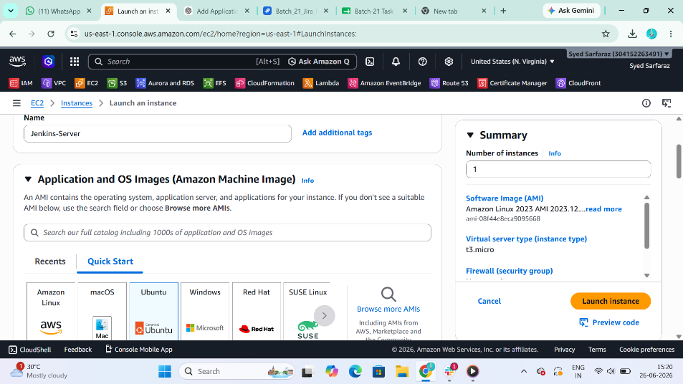
4 Select Number of Instance
5 Create new security group for server security
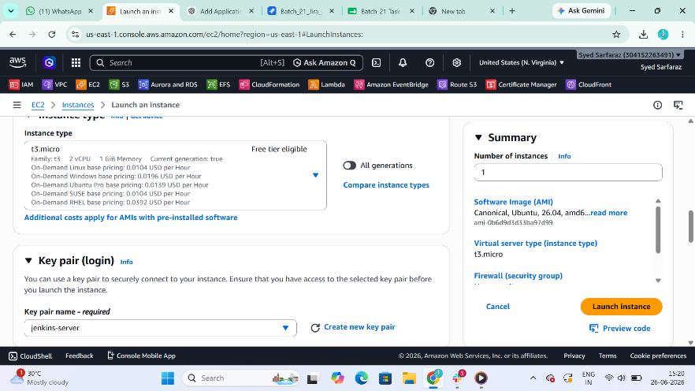

6 Open security group and
Allow ssh
Allow tcp
Allow 8080 port for Jenkins
And Launch the Instance Machine
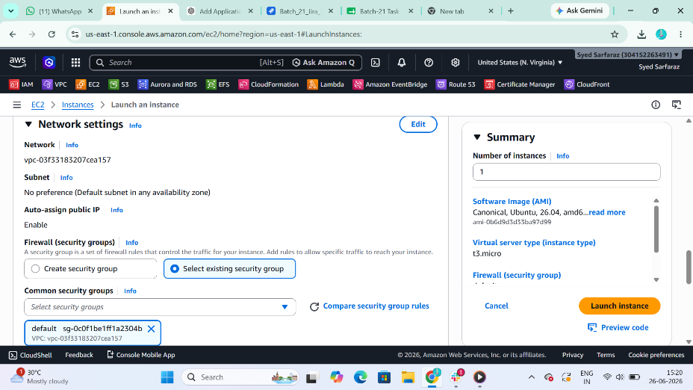

7 Update package by using
$ sudo apt update -y
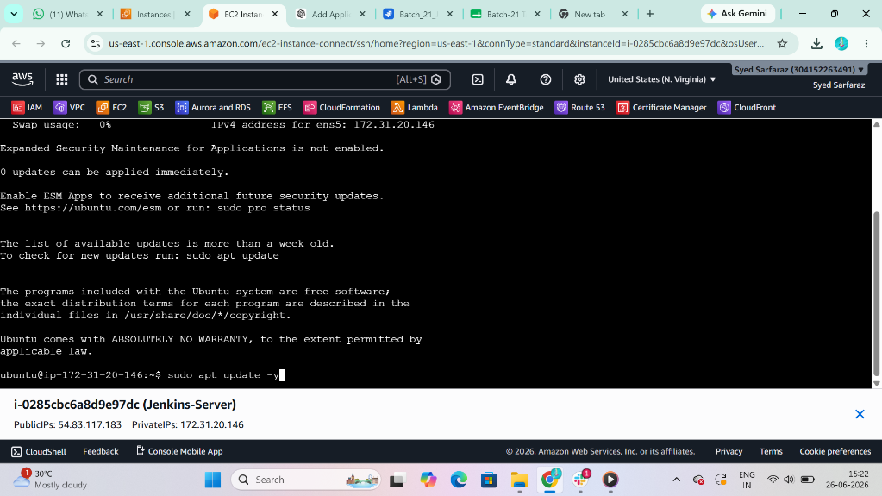

8 Install java for Jenkins because java is the dependency of Jenkins
9 Install Jenkins form its official website by using
$ wget <url>
$ sudo apt update
$ sudo apt install jenkins
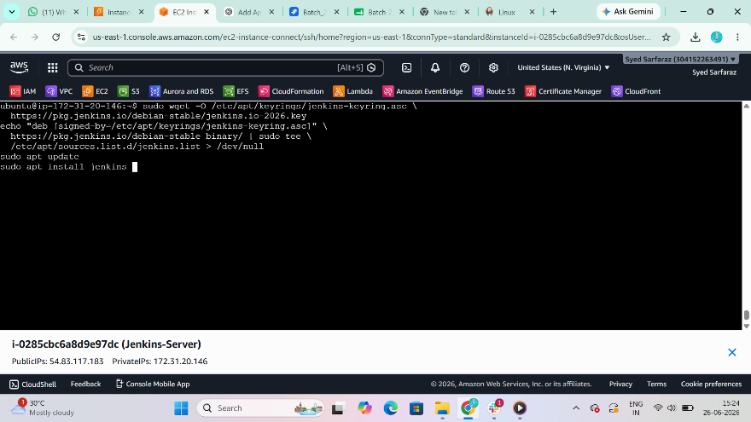

10 After installing start and enable the Jenkins by using the command
$ sudo systemctl start Jenkins
$ sudo systemctl enable Jenkins
$ sudo systemctl status jenkins
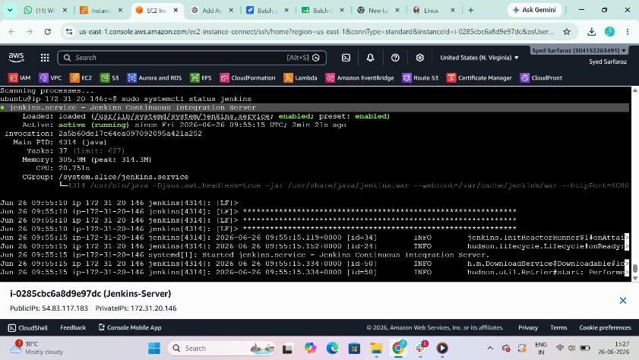

11 After start and enable, copy the instance public ip address and past into the browser with :8080
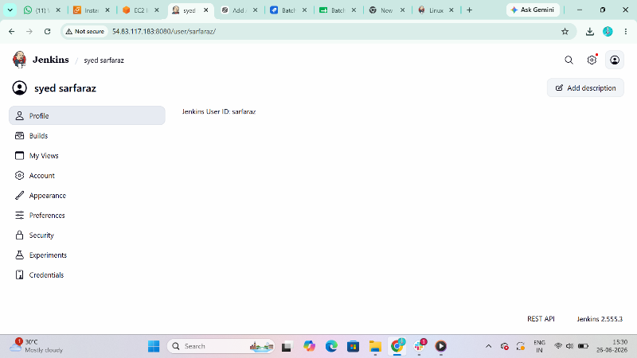

*Apache Tomcat on Ubuntu VM
1 update the package
$ sudo apt update
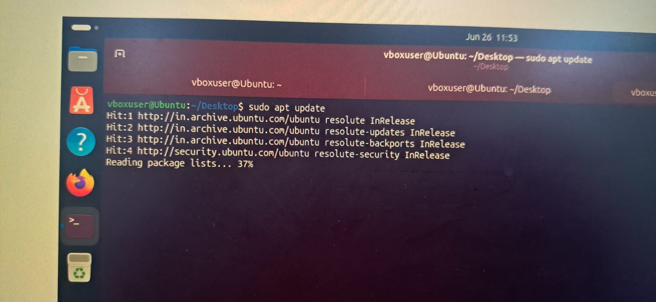

2 Install java for depenceny
$ sudo apt install openjdk-17-jdk -y
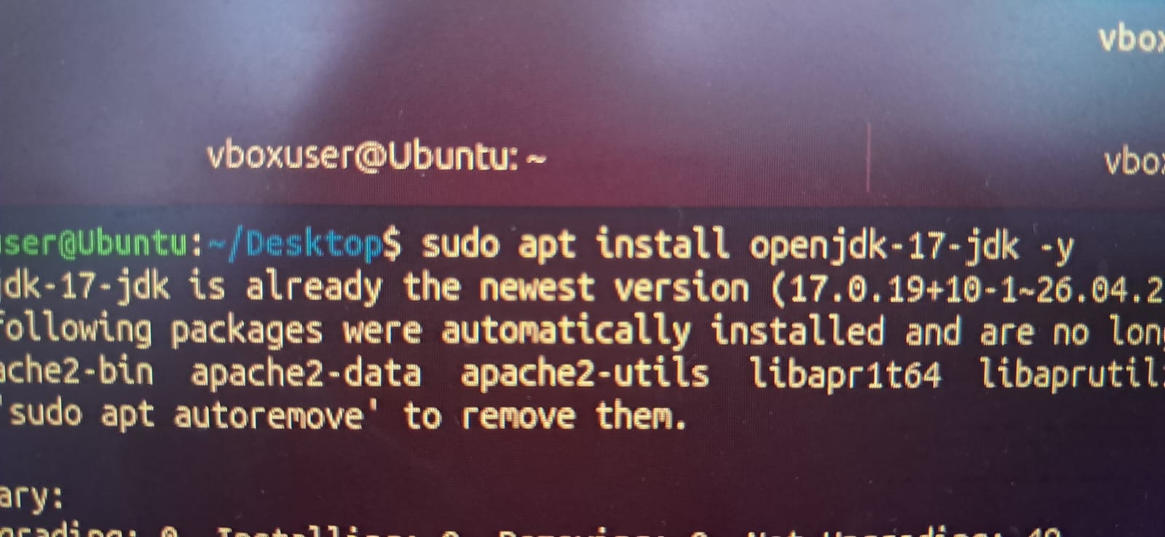

3 $ wget <url>
Past the url to download the Tomcat Apache from the Official website of Tomcat
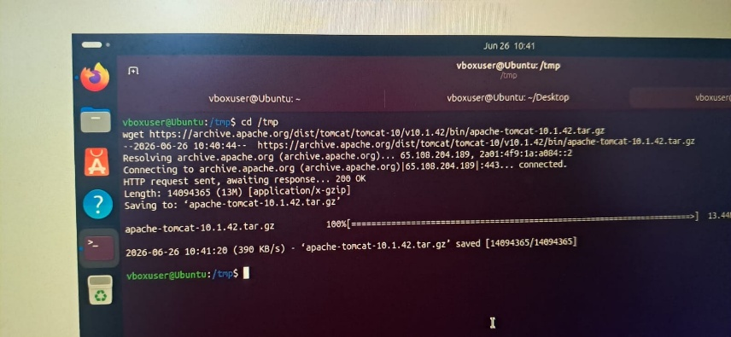

4 Create a Parent directory for Tomcat
$ sudo mkdir -p /opt/tomcat
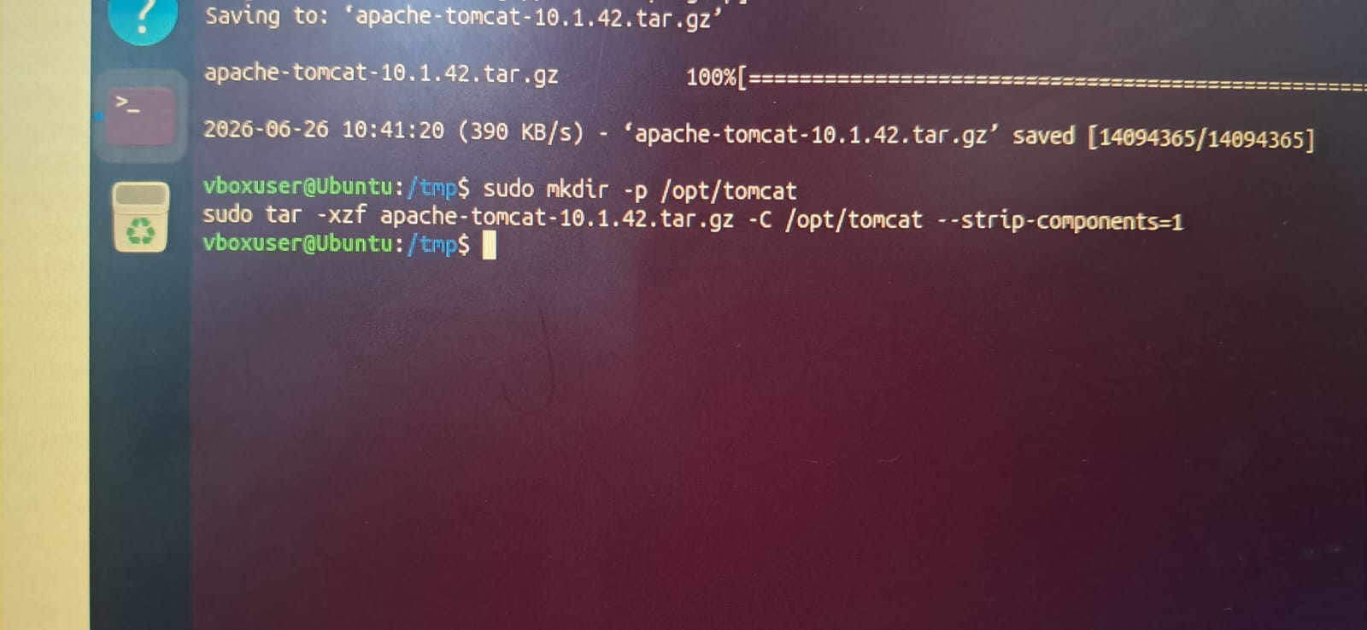

5 Go to browser and search Localhost:8080 in Ubuntu VM
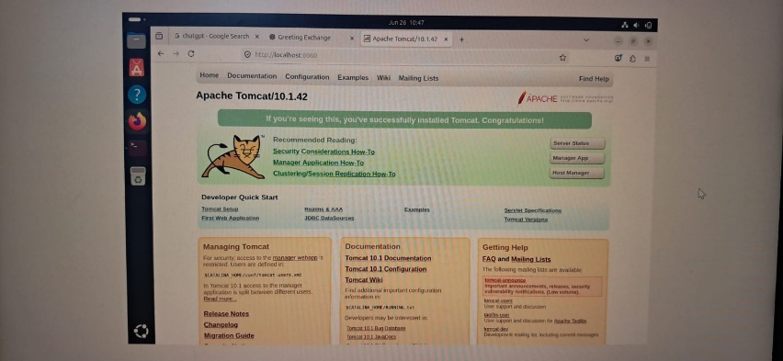

*Docker Desktop on Windows
1 Open PowerShell as Administrator:
$ wsl –install

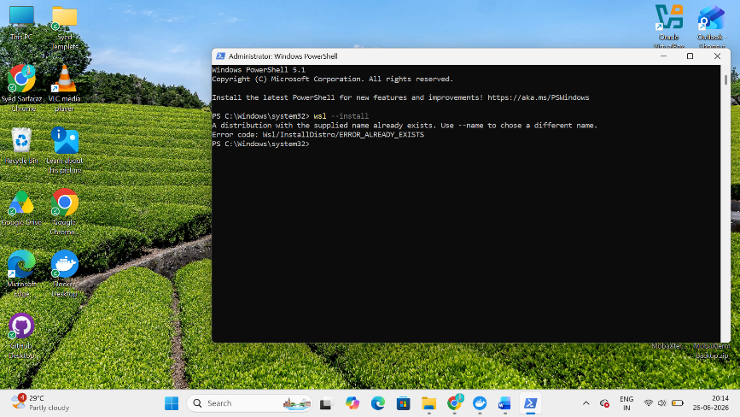
2 Download Docker Desktop From
https://www.docker.com/products/docker-desktop/
Install Docker Desktop using default settings.
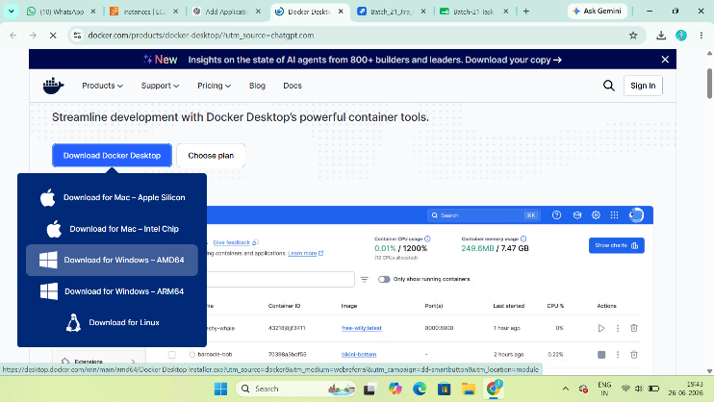

3 Open PowerShell and Verify Docker Installation
$ docker –version
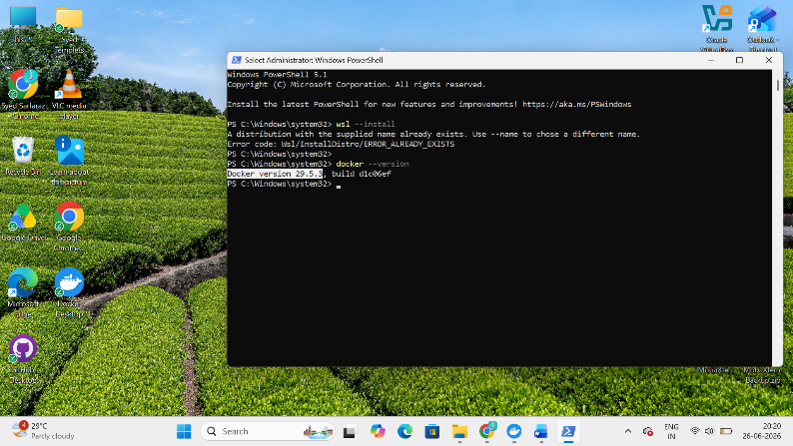

4 Test
$ docker run hello-world
Expected Output: Hello from Docker
